Macroeconomic Report
Fall 2016

Evan Dake
Lucas Busch
Isabel Block
Darren Tjung
Tyler Behymer
Michael Nimmer

Table of Contents
Election 1
Federal Reserve Outlook 2
Select Sector Trends and Outlook 4
Basic Materials 4
Consumer Cyclical 5
Energy 6
Technology 9
Healthcare 10
Industrials 11
Global Climate 12
United States 12
Europe 14
China 17
Conclusion 20

Election
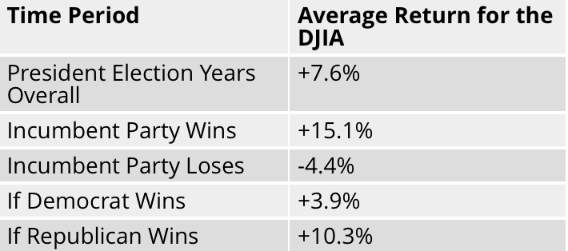
November 8th will prove to be a crucial day for the United States. The two candidates still left standing, Donald Trump and Hillary Clinton, share a very different outlook on how to run the country. This election could see a large change to taxes, immigration policies, healthcare and many other federal regulations. In a study called “Primaries, caucuses and elections–oh my!,” based on data from Ned Davis Research, from 1900 – 2008, they analyzed stock market data using the S&P 500 and DJIA broken down into post election periods. Traditionally when the incumbent party won there were greater gains regardless of political party. Historically the stock market has done better under Republican Presidents than Democratic Presidents.
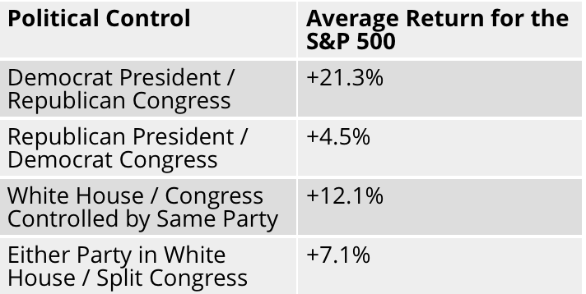
According to this study, more important that who is President is who controls Congress. The combo that has yielded the highest average return for the S&P 500 is a Democratic President and a Republican congress.

Federal Reserve Outlook
Over the past couple of years the Federal Reserve has become one of the main centers of attention in the financial world. The .25% interest rate hike last December has investors wondering when the next one will come, since many believe another one is long overdue.
In all likelihood the Federal Reserve will not increase the Federal Funds rate in November, right before the election, however when their next move will come is significantly tougher to foresee.
A second .25% hike seems highly likely to be coming on December 13th or 14th, which is when the next meeting of the Federal Open Market Committee is scheduled. Bloomberg futures data shows that a rate hike in December is highly likely with 73%. However, most people have been very certain about the next hike taking place for over 6 months now, hence the 27% of the hike not happening. The Federal Reserve has shown that they will wait as long as possible, if that means less volatility.
Given the fact that the Fed has only raises interest rates once within the last ten years, that precedence will weigh heavily into their decision and timing of the next rate hike. The last interest rate raise occurred on December 16th in 2015. For months after, the S&P 500 was plagued by heavy volatility and a severe decline in the index’s value in the first few months after the rate hike.
Of course there were many other reasons that contributed to this short-term downturn like the slowdown in growth of China’s economy, weak overall global growth, and the Brexit in June all contributed to high investor uncertainty. We believe that this perfectly explains the Fed’s patience with raising interest rates, because if even a small increase of 25 base points occurs around the same time as some of these other major negative economic events, a crash in equity prices is very possible.

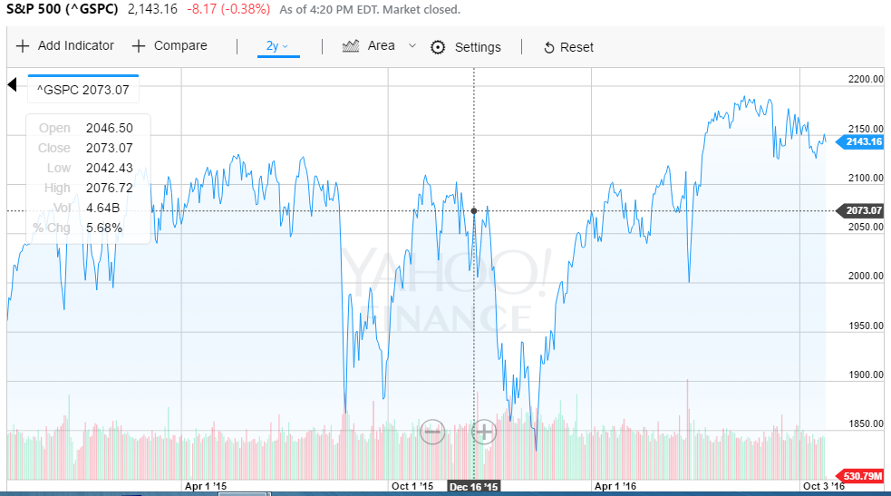
One of the current fears of investors is a potential bubble a in the bond market. With interest rate levels being extremely low in the US, and even negative in Europe and Japan this seems very plausible. As interest rates rise, bonds devalue. The only problem is that for 10 years now the interest rate has been practically zero, leading to a huge inflation in bond prices. One could even argue that because savers have lost the traditional method of saving in a simple savings account, the low level of interest rates has also significantly over inflated equity prices.
These are more reasons why we predict that the Federal Reserve will stay very conservative in raising interest rates. In our opinion, the Federal Reserve will raise interest rates by the same margin once within the next year, if a rate hike occurs this December.
Another fact to consider is that of the 10 members of the Federal Open Markets Committee there are only 3 known so called hawks. Hawks favor higher and more frequent rate hikes, whereas doves favor a more lenient monetary policy that centers around raising rates more slowly. The chairman of the committee Janet Yellen is by many considered a dove, whereas Esther George, Loretta Mester, and Eric Rosengren are considered hawks. Since doves still have a strong majority and Yellen on their side, their views and opinions are likely to prevail at least in the short run.
Another big determinant in the Fed’s decision will be the state of the overall economy. This September the number of new jobs created was under the economists’ predictions. Additionally, the unemployment rate rose slightly, from 4.9% to 5%.
However there were also positives. A slight increase in the labor force participation rate, as well as growth in wages. Overall this last month hasn’t been nearly as spectacular for the economy as recent months, but if the economic report were similar in October and November, a December rate hike would still be highly likely since the Fed would not have any grave concerns to worry about.

Select Sector Trends and Outlook
Basic Materials
In the beginning of the year 2016, the basic materials sector was badly affected due to the decline in commodity prices. This decline in prices was greatly resulted from the slow Chinese economic growth and weak global demand of commodities. But as of recent events, the sector which includes the mining and refining of metals, chemical producers, and forestry products, experienced a bounce in which brought its performance above the market. We believe that the sharp commodity price decline seen over the past couple of years is ending, with global stimulative monetary policies helping to arrest the fall.
A generally positive economic picture of the US, and an accommodative Federal Reserve as well as a slightly improving Europe economy, are potential positives for the basic materials sector. The increased demand for raw materials for infrastructure purposes in developing countries and accommodative monetary policy of central banks that are largely in easing mode, should help stimulate growth in the economies and the basic materials sector.
However, there are uncertainties in the global markets which could affect the economic growth of the sector. One of them being China, one of the global market leaders, experiencing reduced demand and large supplies of inventories which could take time for the stockpile to be worked through. China has also recently transitioned into a net exporter of steel as from a net importer. Apart from that, the European economy is still fluctuating due to the recent exit of the British country and the potential growth of the strength of the US dollar could negatively affect the basic materials sector.
It is important to consider the global business cycle when considering stocks from the basic materials sector. Basic materials are highly volatile as they are subject to supply and demand in the same way as consumer goods. They further respond to the supply and demand of certain materials, particularly precious metals, and supplies the needs of construction, which is also an indicator of market strength. Therefore, consumption patterns change as the prices of commodities move higher and lower.
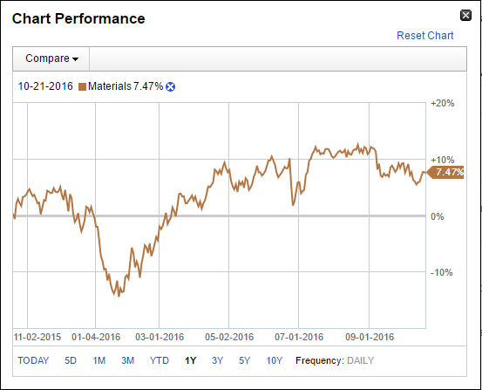
(Fidelity: Basic Materials Sector)
Consumer Cyclical
As revolving debt which includes credit cards and bank loans start to increase as according to the Federal Reserve, the consumer cyclical sector is projected to see a steady growth in the near future. The year end sales in 2016 further projects an expected rise of 3.6%, above the 10-year average of 2.5%. To add on to the continual positive environment of where consumer cyclical is headed, the reduction of debt owed by consumers ever since after the Great Recession and the continually improving job market and steady wage increases are positive factors affecting the sector.
Apart from that, a competitive environment between retail is increasing at a rapid rate as consumers shift from traditional department stores to more online shopping. This competition creates a positive challenge to the consumer cyclical sector as the more businesses adapt to the changing habits of consumers, the more they are able to grow. Furthermore, the current unemployment rate is considered to be at its lowest and wage growth appears to be improving throughout the United Sates.
However, there are some cautions that needs to be taken into consideration when determining which consumer cyclical stock to invest in. The constant evolution of technology of the world poses a threat as fierce retail competition is on the rise. As explained above regarding the increase in online shopping, margins of retail companies are being affected which could translate to the stock performance if measures are not taken to overcome the situation. The rise of millennials and the decline of the baby boomer generation further amplifies the change that business need to make as spending patterns of the two generations differ now as from before the Great Recession. Lastly, if the concern of inflation rate not achieving the 2% mark continues to be evident in the US economy, increasing interest rates to offset the inflation rate could be a hindrance to the consumer discretionary sector.
Consumer cyclical businesses which includes retail, media, restaurants, consumer durables and apparel are affected by the business cycle. It is important to understand that the demand for consumer cyclical goods is typically much more elastic in comparison to consumer staples goods, which means that it can plummet very quickly in response to decreases in consumers' incomes or increases in prices.
Energy
Oil prices have been at its low since the beginning of the year 2015 but it is believed that the current cycle of falling crude prices is close to an end as market fundamentals improve. Oil prices are currently hovering at around $50 per barrel after hitting a 10-year low of less than $30 in January, down from a peak of more than $100 in mid-2014. Market fundamentals, in terms of supply and demand, have begun to improve and countries are taking measures to bring the oil prices back up. Agreements among OPEC members to cut oil production, along with an announcement out of Russia that it too may consider freezing or cutting production, have boosted the oil prices.
In the second quarter of 2016, financial results for many publicly traded U.S. onshore oil producers have showed improvements compared to the first quarter. Cash from operations increased from the first quarter, reflecting higher crude oil prices. Many companies improved operating efficiency, reduced costs, and improved their balance sheets as crude oil prices stabilized. Capital expenditures at these companies also rose in the second quarter from the first quarter, the only quarter-over-quarter increase since 2014 as reported by the US Energy Information Administration (EIA). Furthermore, short term increase of Brent crude oil is expected to rise to $48 per barrel, higher by $3 per barrel from September’s forecast. Positive long term price increases are also said to occur as supply starts to tighten and demand of crude oil increases through the country and the world.

Demand
Energy is intangible to the functioning of the global economy and thus a demand always exists. With that being said, increases in energy efficiency are a strong counterbalance to this demand growth and will keep it modest. Growth in global energy demand will decelerate to 0.7 percent per year through 2050. Emerging and developing countries will drive all growth in energy demand, while European and North American demand will decline.
- Due to the adoption of more-efficient combustion engines and more electric vehicles oil demand in 2035 could be three million barrels below a business-as-usual case. If you include the accelerated adoption of lighter materials in the automotive industry, oil demand could drop by six million barrels. We may see “peak” oil—with respect to demand, not supply—around 2030
- Electricity demand will be strong. The Energy Information Administration projects that 355 gigawatts of new electric generating capacity - or more than 40% more than the industry currently supplies - will be needed by 2020 to meet growing demand. But the electricity-generation mix is changing as solar- and wind-power technology improve and prices fall; wind could become competitive with fossil fuels in 2030, while solar power could become competitive with the marginal cost of natural-gas and coal production by 2025. Fossil fuels will continue to dominate the total energy mix, but renewables will account for about four-fifths of future electricity-generation growth.
- Natural-gas demand has been growing strongly as a source of power generation, especially in the United States and emerging economies.

Renewables
Renewables will rapidly grow in the future but will still hold a market share inferior to fossil fuels. Looking Ahead estimates that nonhydro renewables could more than triple their share of the global power supply by 2040. In the next 25 years, renewables will account for an estimated 43 percent of Africa’s new power plants, 48 percent of Asia’s, and 63 percent of Latin America’s. Asia alone is projected to add 1,587 renewable-power plants, almost as many as the rest of the world combined.
Here’s the contradiction: Even after that boom in renewables, the International Energy Agency (IEA) estimates that the sector’s total share of global electricity generation will be only 17 percent by 2040, because coal (31 percent) and natural gas (24 percent) will continue to be low-cost and reliable sources of power

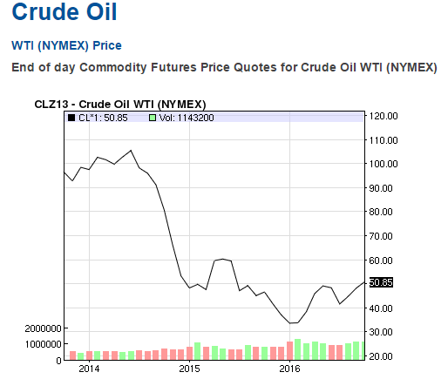
(Nasdaq Crude Oil Price)

In addition to the positive factors of the growing energy sector, the potential increase in energy demand throughout the United States as well as the world will increase growth of the energy sector as more energy is needed to improve infrastructure and to modernize their economies. Accommodative monetary policy will also be a factor to help increase energy prices which will benefit companies providing energy products or services.
Apart from that, renewable energy now takes up 10% of total energy supplied in the United States and is predicted to rise till 80% by the year 2050. The importance of renewable energy is increasing throughout the world as more and more economies use solar, wind, hydroelectric power and more to supply the power needed. The solar industry received a big boost in 2016 as many contracts for solar installation was made then. In 2017, utility demand for solar decreases as the continuation of federal Investment Tax Credit (ITC) becomes certain and there are no urgent demand projected to hit the market in 2017. Despite the slowdown in 2017, it is highly projected that solar demand will steadily increase as the years go by and this goes for the same for other sources of renewable energy.
The following years for the energy sector are somewhat uncertain as the 2016 US presidential election will greatly affect the market economy. The following points taken from a Schwab analysis shows potential impacts on different areas of the energy sector if either candidates come into power:
Democratic Party, Hillary Clinton:
- Energy sector would be one of the clearest beneficiaries in the form of renewable energy
- Clear on advocating further advances of renewable energy
- More subsidies
- Limiting amount of fossil fuels and mandating “renewable” energy
- Renewable/alternative energy companies are believed to benefit from this candidate’s win.
Republican Party, Donald Trump:
- Skepticism over the extent of manmade climate change – limit government subsidies on investments in alternative energy.
- Advocate for American energy independence through traditional sources of energy
- Traditional energy companies are believed to benefit from this candidate’s win.
Technology
In the transition into 2017, expect to see positive performance in the Technology sector as well as a number of positive changes taking place. It should be noted that out of the top five industries in Q3, four of the industries belong to the Technology Sector. Furthermore, the Technology Hardware, Storage and Peripherals Industry had the highest returns of around 20%.
On another note, there is a current transformation taking place within the industry of financial services and technology (Fintech), with mobile banking startups paving the way for a new automated banking industry. A study from Citigroup reported that in the coming years, up to 30% of jobs in traditional banking could be lost to automated banking services. Moreover, we will see more and more services outside of banking begin to go mobile and automated.
Additionally, companies such as TESLA motors are pioneering the world of autonomous vehicles, with other companies such as Lyft, GM, BMW, Uber, and Ford all setting goals of releasing driverless cars as soon as possible. This race towards driverless cars and taxis will have an enormous impact on the technological sector and there will be a continued boost in technology spending as companies aim towards technological innovation.
Startups will continue to be an important factor within the technology sector, with many entrepreneurs delving into the world of marijuana tech after seeing the profits made after Colorado legalized marijuana. For example, one medical marijuana technology company by the name of Eaze has raised over $25 million in venture capital, which puts it at the most funded marijuana tech company in the world.
A few negative factors that could affect the technology sector include an increase in global competition which could diminish profit margins within the field of information technology. Within the IT sector, annual revenues are expected to be somewhat flat. Yet, the CompTIA IT Business Confidence Index saw a slight increase and is expected to remain stable at 61.7 out of 100 in the coming year.
Overall, the technology sector can be expected to outperform the market as a whole, with the Information Technology sector making up a 21% of the S&P 500 Index and having an 11.8% year-to-date total return as of early October.

Healthcare
Typically, the demand within the healthcare sector remains relatively stable regardless of the economic situation, so the broad trends within the healthcare industry will continue; thus, the outlook into 2017 will be similar to the 2016 outlook. That being said, there are a number of both positive and negative factors influencing the healthcare sector outlook that should be noted.
For example, the demand for healthcare will continue to increase due to the rapidly increasing elderly population and rise in obesity in America. Additionally, the field of personalized medicine is growing precipitously with 94% of companies investing in research for new therapeutic and precision medicine treatments. Another positive factor influencing the outlook is that the many corporate balance sheets have high amounts of cash, which indicates strong financials among the sector and room for productivity increase. Finally, the trailing price to earnings ratio of the sector low, and in the past a low trailing P/E has strongly correlated with outperforming the S&P 500 Index in the following year.
On another note, the biotechnology and pharmaceutical industry has been hit hard after public outrage due to drastic price increases. For example, biotech stock prices fell sharply after Democratic candidate Hillary Clinton chastised Martin Shkreli over Twitter for increasing drug prices by around 5000%, as well as the more recent increase in the price of Epipen allergy medication. This trend has been occurring for a few years and it should be expected that this public and political criticism will persist into 2017. Also, the political situation in the United States will likely have huge repercussions for the healthcare sector, especially related to the Affordable Care Act, the TPP regarding its extension on pharmaceutical patents, and government drug pricing regulation.
The healthcare sector outlook is relatively neutral and the sector is expected to market perform. Recently, the healthcare sector’s valuation has improved with respect to other sectors, however the outlook remains neutral. This is due to the balance of positive factors, such as the increase in demand and innovation, and negative factors, such as public criticism and political uncertainty, both affecting the outlook.

Industrials
The industrial sector has a neutral outlook for 2017. The P/E estimate for this year is 19.02, which is slightly lower than the trailing P/E of 23.99. The enterprise value for the sector is at $67.61B, and the trailing twelve months’ revenue growth compared to the prior twelve months was 1.07%, expressing small increase in revenue. As of late September the sector had a dividend yield of 2.2, and returns have slowed down to 4.1% from a 10.9% year-to-date.
Positive factors affecting the outlook include the room for growth and potential productivity increases do to cash rich corporations. Also as long as oil prices remain low, the Aerospace and Defense Industry which makes up the largest portion of Industrials should be expected to perform well. Despite the cheap oil prices, energy efficiency will still continue to be a concern of businesses due to both government regulation and cost minimization.
Additionally, the US Institute for Supply Management released a Manufacturing index of 51.5 indicating an expanding manufacturing industry. Looking forward, the Internet of Things, 3D printing advances, and robotics are all transforming the manufacturing industry, as has been seen in China. These technological innovations will have profound effects on industrials by helping industries improve efficiency and decrease labor costs.
Alternatively, there are some negative influences affecting the industrials sector such as limited access to credit among smaller businesses and a pattern of increasing debt assumed by companies which may indicate weak fundamentals. Despite these factors, overall the Industrials sector appears to have a neutral outlook for the coming year and is expected to market perform.

Global Climate
United States
The United States is one of the strongest economies in the world and will most likely remain its position. On the one hand a strong U.S. dollar is weighing on exports, while low oil prices and rising election uncertainty continue adding pressure on the business environment. On the other hand, a solid labor market and consumer confidence are boosting household spending. Consumer prices in the United States went up 1.5 percent year-on-year in September of 2016, higher than 1.1 percent in August and in line with market estimates. It is the highest inflation rate since October 2014.
Despite the higher prices, the US dollar increased in value during the last five years. The United States Dollar Index or DXY measures the performance of the dollar against a basket of other currencies including EUR, JPY, GBP, CAD, CHF and SEK. The DXY changed +3.17 percent during the last month and +2.40 percent during the last year.
As a consequence of a strengthened dollar, exports decrease and imports increase. The US goods and services deficit increased 3 percent to $40.73 billion in August of 2016, slightly worse than market expectations of a $39.3 billion. Imports increased by 1.2 percent, the highest since September last year while exports rose 0.8 percent, the highest since July of 2015. The increase in imports is boosted by capital goods; civilian aircraft; telecommunications equipment and other goods. Imports of services increased $1.5 billion to $43.0 billion: charges for the use of intellectual property increased $1.2 billion. The increase reflect payments for the rights to broadcast the 2016 Summer Olympic Games. Travel went up $0.2 billion. The increase in exports was boosted by industrial supplies and materials; nonmonetary gold and automotive vehicles, parts, and engines. Exports of services increased $0.3 billion to $62.5 billion: travel increased $0.2 billion; transport, which includes freight and port services and passenger fares, rose $0.1 billion.
The Gross Domestic Product (GDP) in the United States remains increasing since the year 2006. The GDP was worth 17947 billion US dollars in 2015, and remains increasing. The GDP value of the United States represents 28.95 percent of the world economy. United States economy expanded an annualized 1.4 percent in the second quarter of 2016, more than 1.1 percent reported in the second estimate and much better than 0.8 percent reported in the first three months of 2016. The increase in real GDP in the second quarter reflected positive contributions from personal consumption expenditures (PCE), exports, and nonresidential fixed investment. These were partly offset by negative contributions from private inventory investment, residential fixed investment, and state and local government spending.
Industrial output in the United States increased 0.1 percent month-over-month in September of 2016, following an upwardly revised 0.5 percent fall in August and below market expectations of a 0.2 percent gain. Manufacturing and mining rebounded while utilities fell. For the third quarter as a whole, industrial production rose at an annual rate of 1.8 percent.
Household Saving Rate in the United States remained unchanged at 5.70 percent in August from 5.70 percent in July of 2016. The savings rate increased compared to January 2016, when it was 5.2 percent, to 5.7 percent in August. So did minimum wages. Minimum Wages in the United States remained unchanged at 7.25 USD/Hour in 2015 from 7.25 USD/Hour in 2014.
The Federal Reserve left the target range for its federal funds rate unchanged at 0.25 percent to 0.5 percent for the sixth time during its September 2016 meeting. Policymakers said that the case for a rate hike has strengthened but decided to wait for further evidence of continued progress toward its objectives.
The United States recorded a Government Debt to GDP of 104.17 percent of the country's Gross Domestic Product in 2015, an increase compared to 102.98 in 2014, see the graph below. This is because imports increased more than exports. Consequently, US unemployment rate increased to 5 percent in September 2016, compared to 4.9 percent in the previous month. For the 2016 fiscal year, the country's budget deficit widened to 3.2 percent of the GDP, the highest in three years.
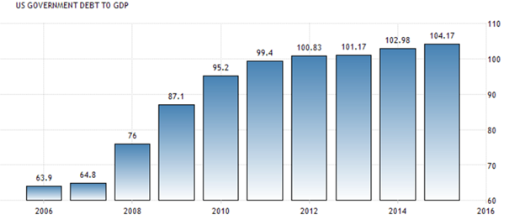

Although the U.S. is facing difficulties, such as the increasing unemployment rate and budget deficit, the prediction is that the GDP growth rate and the industrial production will increase further. Inflation is expected to increase to 2.5% in 2020 (compared to 1.5% now).

Europe
Europe has a lot to work on in terms of economic recovery. The economic recovery in Europe is expected to continue, see the graph below. The euro area GDP in 2015 was revised notably upwards due to a large upward revision in Irish GDP, which in turn reflected the restructuring of large multinational enterprises leading to a strong increase in the level of capital assets in Ireland.
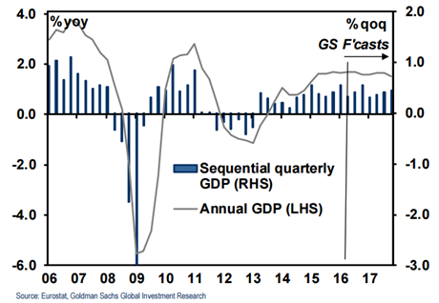
The Euro GDP growth moved from 0.5% in the first quarter 2016 to 0.3% in the second quarter 2016. Euro export growth is expected to decrease due to a much weaker import demand in the United Kingdom because of the referendum on EU membership. The Brexit vote has had little impact on sentiment and uncertainty indicators in the euro area so far. Indicators of financial market volatility and overall macroeconomic uncertainty stayed low. Low oil prices, improving labour market conditions should support growth in domestic demand in a context of gradual global recovery. Looking at the future; the impact of the UK decision to leave the European Union is expected to adversely affect the euro area economy, mainly via trade linkages, as the outlook for the UK economy has been significantly revised downwards. United Kingdom GDP growth is expected to slow notably in the second half of 2016 and 2017. This is due to a marked decline in investment and slower private consumption growth. Corporates deal with uncertainty related to the outcome of trade negotiations, the future relations between the United Kingdom and the European Union are not clear.
Therefore, UK imports were revised substantially downwards. The UK exports growth is also being revised downwards, but by less, as it is expected to be supported by the depreciation of the pound. The UK decision has an expected negative effect on the euro mostly through lower exports. The adverse effect on real GDP growth from lower foreign demand varies across euro area countries, reflecting differences in trade linkages with the United Kingdom. There are also country specific, Brexit-related exchange rate effects from the strong depreciation of the pound against the euro. But for euro area countries this appreciation of the euro against the pound was offset by the depreciation of the euro against other major currencies. In addition, there have been downward revisions in long-term interest rates, which may reflect the changes in expectations of future euro area and global monetary policy. In conclusion, up till now Brexit has had little impact on sentiment and uncertainty, but euro export is expected to decrease in the future.
Besides this, Greece is still suffering from the sovereign debt crisis. The crisis has a significant effect in terms of inequality and increased poverty. There is an acute social emergency that is manifested by mass unemployment and rapidly falling incomes. Greece is unlikely to meet obligations for repayment on time. The continual extension from repayment is not a solution to the crisis. There is an ongoing debate if Greece should leave the EU or not. The costs for an exit are high, as it must change its currency to the drachma again. It could be as high as 40-50% of GDP for the exciting countries. But the alternative, a decade of depressive deflation would be much worse for Greece. If Greece would not exit the EU, the slow and depressive deflation that is needed to restore competitiveness will reduce the real euro value of the purchasing power of Greek euro denominated assets over foreign goods and assets. Assets in non-tradable sectors of Greece, such as real estate, would be 30% lower in euro value after the deflation has occurred. The real value of Greek assets will also be 30% lower, if a 30% fall in prices is needed to restore its competitiveness. So, Greece will be 30% poorer regardless of whether the depreciation occurs via deflation or via a nominal depreciation.
In March 2016 the inflation rate was -0.2 percent. Low inflation is a big concern for officials at the ECB. The disflation and even deflation indicated accommodative monetary policy until inflation goes up again. The ECB wants to drive up inflation to the 2 percent target. The European Central Bank reveals that inflation has increased from -0.2 in March 2016 to 0.4 in October 2016.The Euro area labor market conditions should continue to improve over the projection horizon. Employment is projected to continue to rise. The expectation is that the labor productivity growth will increase from 0.4% in 2016 to 0.9% in 2018. The unemployment rate (as a % of labor force) decreased from 10.9 in 2015 to 10.2 in 2016, to be precise to 10.1 in August 2016.
The euro area is still recovering which discloses a weak euro. Over the past six months, the dollar has strengthened in comparison to the euro. The graph shows a depreciation of the Euro versus the Dollar. On the 3rd of May 2016 1€=$1.1569 and on the 21st of October 2016 1€=$1.0886.
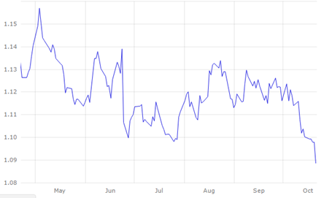
A strong dollar means U.S. goods and services are more expensive and U.S. imports will increase. This in turn will increase the U.S. budget deficit. In contrast the exports of Europe are boosted due to a depreciation of the euro. This leads to a decrease in Europe’s budget deficit. The deficit of Europe decreased from -2.6 percent in January 2015 to -2.0 percent in April 2016. Real GDP in Europe is expected to grow by 1.7 percent in 2016 and by 1.6 percent in 2017 and 2018. Europe seems to slowly recover from its financial crisis. Since the unemployment rate is decreasing, GDP is rising and the government budget deficit is decreasing the future looks brighter.

China
China is one of the fastest growing countries in the world. In 1978—when China started the program of economic reforms—the country ranked ninth in nominal gross domestic product (GDP) with USD 214 billion; 35 years later it jumped up to second place with a nominal GDP of USD 9.2 trillion. China is the world’s largest exporter and remains the second largest economy, behind the United States. China has used its control over its exchange rate to help ward off global financial crisis and maintain his dominant position.
The industrial production in China rose to 6.1 percent in September 2016, compared to 6.0 percent in July. Output rose the most for electricity, gas and water production (+7.3 percent), followed by manufacturing (+6.5 percent) and mining (+0.1 percent). Meanwhile, fixed-asset investment grew by 8.2 by percent in January to September 2016 from a year earlier, up slightly from 8.1 percent increase in January to August and in line with consensus. Industrial Production in China averaged 12.53 percent from 1990 until 2016. So, in general the industrial production is declining, from 12.53 to 6.1 percent. China is losing more and more comparative advantage as a manufacturing economy due to rising wages.
The National Bureau of Statistics of China revealed that the inflation rate reached a high in September 2016 of 1.9 percent, compared to a 1.3 percent rise in August. The market expected an increase to 1.6 per cent. The high inflation rate was due to politically sensitive food prices which increased by 3.2 per cent while non-food cost increased with 1.6 per cent.
Credit and monetary conditions continue to improve. Chinese banks had extended new loans in August of CNY 949 billion, which increased in September to CNY 1.22 trillion. This overshot het CNY 1.00 trillion the markets had expected. Total social financing, a broader measure of credit and liquidity in the economy, that includes loans, bonds and other non-traditional instruments jumped from August’s CNY 1.47 trillion to CNY 1.72 trillion in September. Besides this, annual growth of the money supply rose from 11.4 percent in august to 11.5 percent in September. The average GDP Growth rate average in China is 1.85 percent from 2010 to 2016. The Chinese economy expanded to 1.8 percent in the third quarter of 2016, in line with the estimates.
China’s government debt is showing an increase since 2010. China recorded a Government Debt to GDP of 43.90 percent in 2015, compared to a 41.1 per cent in 2014. Government Debt to GDP in China averaged 34.36 percent from 1995 until 2015.
The Chinese renminbi (yuan) increased in value over the last years. The USDCNY increased by 6.41 percent during the last year. This leads to a decrease in exports. Consequently, the trade surplus in 2015 was USD 59.60 billion, which decreased to 41.99 USD billion in September 2016, see the table below. It was the smallest trade surplus since March as exports fell much more than imports. In 2016 exports declined 10 percent compared to a year earlier. Imports unexpectedly decreased by 1.9 percent. In yuan-denominated terms, sales fell 5.6 percent from a year ago. Balance of Trade in China is reported by the General Administration of Customs.
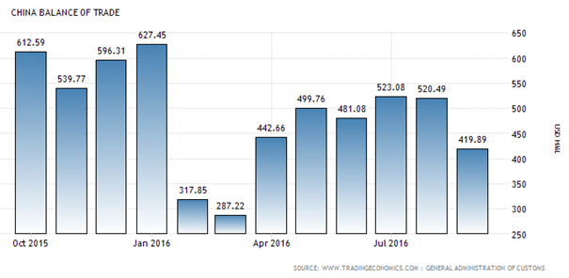
Investment in China shows a down-sloping growth, see the graph below. A month-on-month comparison shows that investment in urban fixed assets rose a 0.52 per cent in September 2016, which was below the 0.52 percent increase in August. September’s data reveals that investment growth among state-owned and state-holdings unites moderated slightly, it still expanded 21.1 percent. Activity among private companies accelerated in September and expanded 2.5 percent. Despite this improvement, the strong growth in investment among government related industries signals that the public sector continues to be the main source of investment growth at the expense of the private sector.
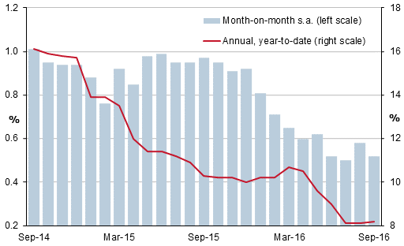
Despite the GDP growth rate increased, the National Bureau of Statistics said that many uncertain factors in the economy remain. It also acknowledged that the foundation for sustained growth is not solid. Inflation is rising and China is losing more comparative advantage due to rising wages. The yuan is expected to strengthen even more which leads to a decrease in trade surplus. Government debt is increasing, but credit and monetary conditions continue to improve. Industrial production is increasing and urbanization is likely to remain an important source of productivity growth in the coming decade.

Conclusion
The United States will most likely remain its position. A strong U.S. dollar decreases exports, and low oil prices and rising election uncertainty continue adding pressure on the business environment. But a solid labor market and consumer confidence are boosting household spending. The government debt is rising but the GDP increased significantly and will do so in the future. Europe seems to slowly recover from its financial crisis. Since the unemployment rate is decreasing, GDP is rising and the government budget deficit is decreasing the future looks brighter. The outcome of a Brexit and a possible Grexit is uncertain. The strong economy of China is also facing difficulties. Inflation is rising and China is losing more comparative advantage due to rising wages. The yuan is expected to strengthen even more which leads to a decrease in trade surplus. Government debt is increasing, but credit and monetary conditions continue to improve. Industrial production is increasing and urbanization will lead to productivity growth.

